High Doses of Hormones Faulted in Fertility Care
Heather Ainsworth for THE NEW YORK TIMES

Published: July 16, 2012
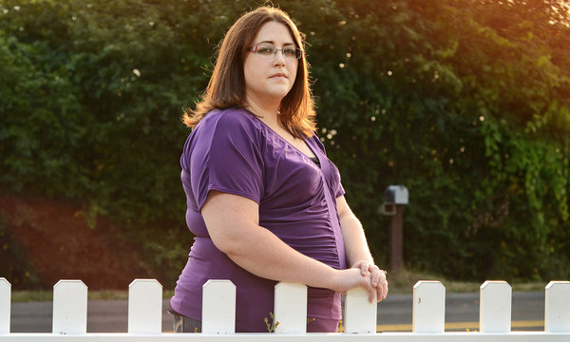
After in vitro fertilization, Debra Demidon experienced a serious complication.

By JACQUELINE MROZ
Doctors diagnosed severe ovarian hyperstimulation syndrome (OHSS), a complication seen in some women who undergo fertility treatment. It landed Ms. Demidon in the hospital for five days; doctors ultimately drained 6.5 liters of fluid from her body. She missed three weeks of work, and by the time it was over, she and her husband had spent all of their savings.
“It was my first time doing IVF, and I’ll never do it again,” said Ms. Demidon, 28, a quality assurance specialist in Cayuga, N.Y. “It was awful. When you have that much fluid in you, it puts pressure on everything.”
OHSS is a little-known complication of fertility treatments that rely on high doses of hormones, which are standard in the United States and the United Kingdom; the syndrome is not the only health problem to be linked to in vitro fertilization. Fertility clinics in Europe and Japan have turned to a safer, low-dose form of IVF, but clinics here have largely resisted on the grounds that the success rates for low-dose IVF are not as high.
“Pregnancy rates are lower, and more cycles of IVF are necessary” with low-dose IVF, said Dr. Glenn L. Schattman, a fertility doctor at NewYork-Presbyterian/Weill Cornell Medical Center and president of the Society for Assisted Reproductive Technology.
But some critics are urging the industry to reconsider.
“Mild stimulation is clearly much healthier for women,” said Francine Coeytaux, founder of the Pacific Institute for Women’s Health, a nonprofit organization based in Los Angeles. “The reason hyper-stimulation happened is because these fertility clinics compete against each other by posting their success rates.”
In high-dose IVF, a woman is first given injections of a drug, often Lupron, to suppress her ovaries, causing temporary menopausal symptoms. Then the ovaries are stimulated with hormones, such as follicle-stimulating hormone and luteinizing hormone, in order to produce more eggs. The duration of stimulation is longer, and the hormone dose significantly higher, than in the low-dose programs common overseas.
Women normally generate one egg per cycle, but high-dose stimulation can help women produce 20 to 30 eggs, or even more. By contrast, women receiving mild, low-dose IVF produce 8 to 10 eggs. The ovaries are not suppressed at the outset, and there is no manipulation of the patient’s cycle.
According to the National Institutes of Health, high-dose stimulation leads to OHSS in 10 percent of IVF patients. The ovaries become swollen and, as in Ms. Demidon’s case, can leak fluid into the chest and abdomen. Symptoms can range from mild to serious; in rare cases, OHSS can be life-threatening.
A recent inquiry into maternal deaths in the United Kingdom found that OHSS following high-dose IVF is now one of the leading causes of maternal mortality in England and Wales. But it may not be the only complication. One recent study suggested that high-dose IVF contributes to lower birth weights, compared with the babies of women who receive minimal doses of hormones. And experts have debated for decades whether IVF contributes to an increased risk of breast and ovarian cancer; studies have reached conflicting conclusions.
Lupron, used to suppress the ovaries, has raised concerns as well. The drug is approved to treat prostate cancer; its use in IVF is off-label (meaning it is not FDA-approved for this purpose). Thousands of women have reported adverse reactions, including memory loss, liver disorders, bone loss and severe muscle, joint and bone pain, said Marcy Darnovsky, associate executive director of the Center for Genetics and Society, a public interest group in Berkeley, Calif.
“Lots of drugs are used off-label, but is this use appropriate?” said Ms. Darnovsky. “Considering the number of women who’ve taken these drugs over the past 25 years, you’d think much more rigorous studies and analysis would have been done on them.”
Because of these concerns, some reproductive specialists are switching to a milder form of IVF. The low-dose technique relies on fewer drugs to stimulate the ovaries, and can result in fewer complications and a quicker recovery time.
Dr. Pasquale Patrizio, a professor of obstetrics and gynecology at Yale University and director of the Yale Fertility Center, said he has been using low-dose IVF with good results. “It’s a shift of minds in the last few years, as we’ve been realizing that there’s no need to stimulate ovaries so aggressively as we’ve done before,” he said.
But other experts say that because the low-dose method produces fewer eggs, women have lower pregnancy rates per cycle. It could take more cycles, and perhaps more money, for a woman to conceive.
“By doing more cycles, there are greater risks by exposing women to more medication, more egg retrievals, and more anesthesia,” said Dr. Schattman of NewYork-Presbyterian/Weill Cornell Medical Center. “It’s not patient-friendly, and you’ll find lots of doctors who don’t agree with it.”
The exorbitant cost of standard IVF — $15,000 to $30,000 per cycle, often not covered by insurance — can prevent women from doing more than one or two cycles. Many women, and their doctors, believe that high-dose IVF increases the odds of conceiving without multiple cycles.
Dr. William E. Gibbons, director of the division of reproductive medicine at Baylor College of Medicine and an early pioneer of IVF in the United States, said he does not believe that the data support a switch to mild IVF.
“More eggs equals more embryos and a better chance of pregnancy — and standard IVF produces more eggs,” he said.
But low-dose IVF can be much less expensive, costing only about a third of standard IVF, according to Dr. Patrizio. The drugs are cheaper (about $500 per cycle), less medicine is necessary and less monitoring is needed, he said.
Because it also reduces the risk of OHSS, fewer patients require hospitalization, Dr. Patrizio added, reducing costs even more.
Dr. Geeta Nargund, president of the International Society for Mild Approaches in Assisted Reproduction, has been at the forefront of using low-dose IVF in England.
“It’s a win-win situation,” she said. “We can offer successful IVF to women while protecting their health and safety, and making it better for their children, at a lower cost. Mild-stimulation IVF is also significantly better for the quality of the embryos and the birthrate of children.” The physical and emotional discomfort for women is significantly lessened, she said; in fact, most women don’t feel anything.
“If we can have IVF stimulation at a lower cost and without OHSS,” Dr. Patrizio said, “then it would be a great step forward for the United States.”

